**GLOBAL ELECTRONICS (POWER BI)**

The dataset of Global Electronics ranges from January 2016 to February 2021. For this data analysis, we are seeking to understand the sum of profit generated by the sales of the products and the performance of the stores.

**Details About Dataset**

This dataset conveys the details of sales of products by Global Electronics which contains six tables, namely; customers table, products table, sales tables, stores table, exchange rates table, and data dictionary table. These tables are in .csv file format.

Customer table contains customer details such as name, gender, state, and country. The products table contains details about the products such as product key, product name, brand, color, unit cost in USD, Unit price in USD, subcategory, and category. The sales table contains sales details such as order number, order date, delivery date, customer key, store key, product key, quantity and currency code. The store table contains store key, country, state, open date. The exchange rate table contains details such as date, currency, and exchange rate. And the dictionary table contains the details about the tables and the columns in each table.

﻿**Data Analysis**

The data analysis has revealed an increase in profit from 2016 to 2019. The year 2016 had a profit of $4.107M while 2019 had a profit of $10.698M, which is a 160.48% increase. The data also showed a decline in profit from year 2020 and 2021. Year 2020 shows a 49.08% decrease in profit from year 2019. The percentage profit of 2021 is not calculated because it is not a full fiscal year.

February had the highest profit which is 1,187.44% higher than April, which had the lowest profit. February accounted for 14.14% of Sum of Profit. The computer categories and the cell phones categories were the highest profit generating categories in February of years 2018 to 2021.

﻿﻿ ﻿﻿At $6.673M, the online store (with storekey 0) had the highest profit and was 70,045.76% higher than storekey 2 located in Northern Australia, which had the lowest profit at $9,513.﻿﻿ ﻿﻿ The online store accounted for 20.43% of the total profit.﻿﻿ ﻿﻿ ﻿﻿Across all 58 stores (having 58 storekeys), sum of profit ranged from $9,512.610 to $6,672,692.640.

Total Profit and total quantity of products sold are positively correlated with each other.﻿﻿ ﻿﻿

**Recommendation**

The data showed that April had the least sales. Why? The sales procedures in April should be looked into, and also, marketing department should come up with strategies that can possibly increase sales especially is April.

More investigation is recommended in order to determine the reason for the decline in sales from year 2020.

**Screenshots of Project** 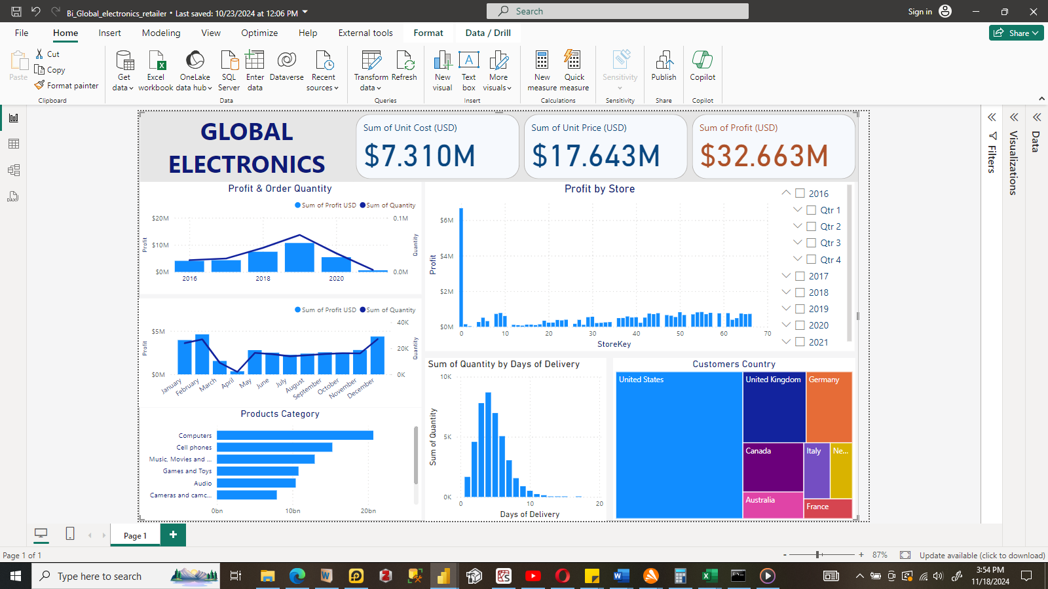

Fig 1 – Dashboard

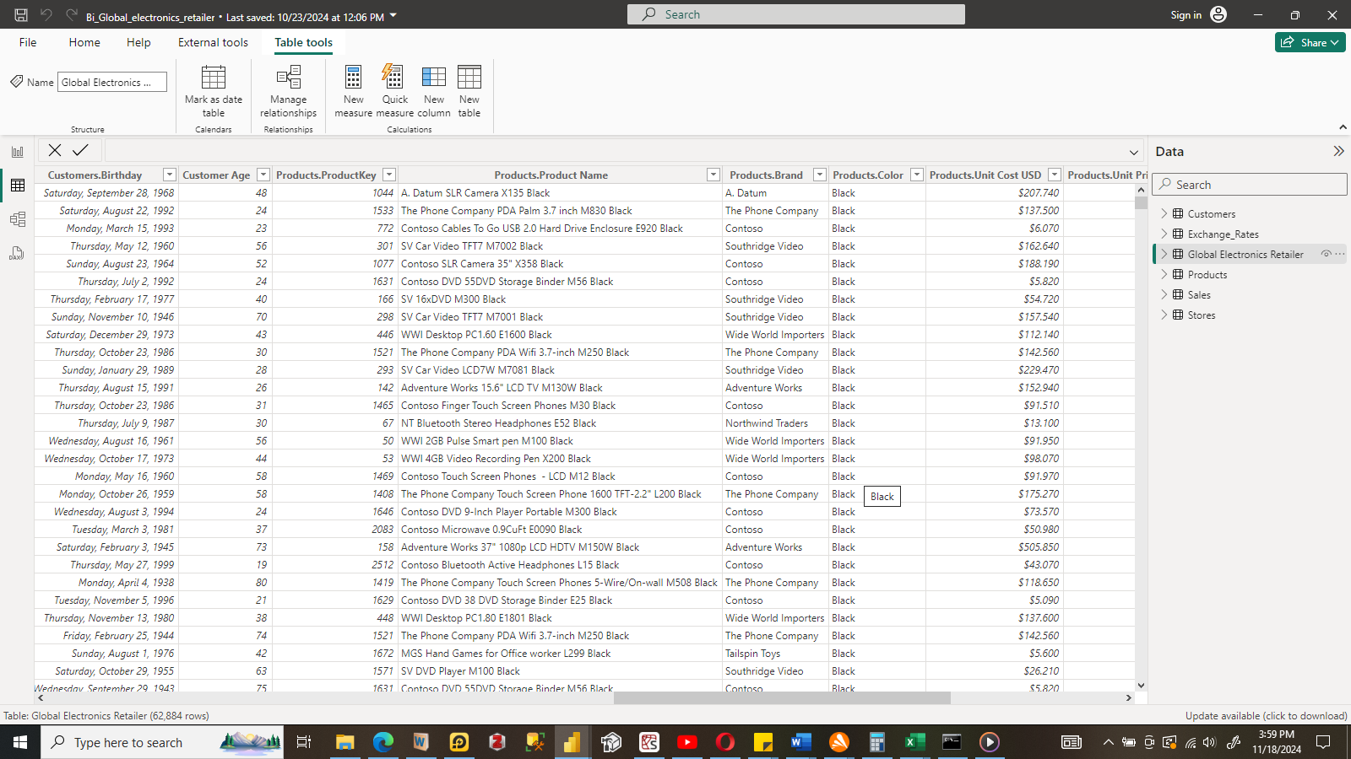

Fig 2 – Table